SLANGFIELD PAGE TEMPLATE
This document is to give a guideline on how the website pages will look like.
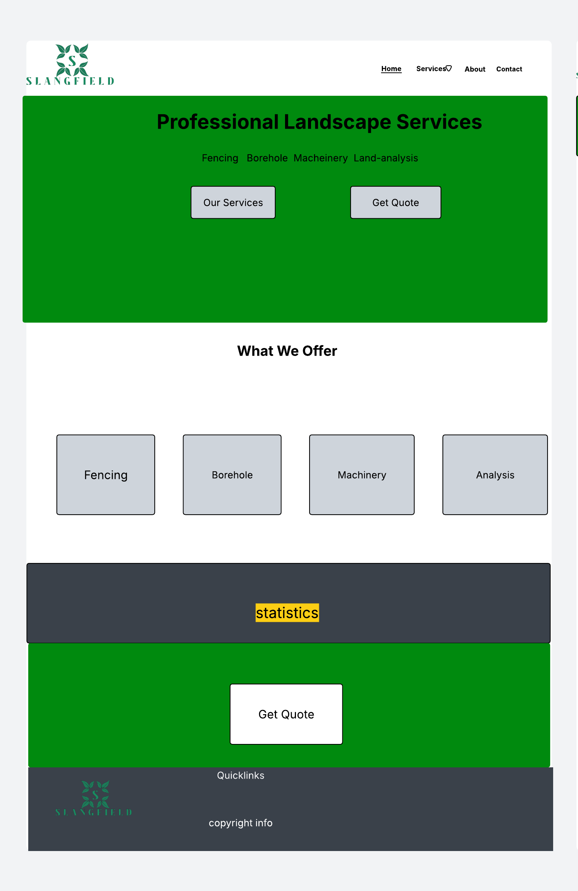
HOME PAGE TEMPLATE

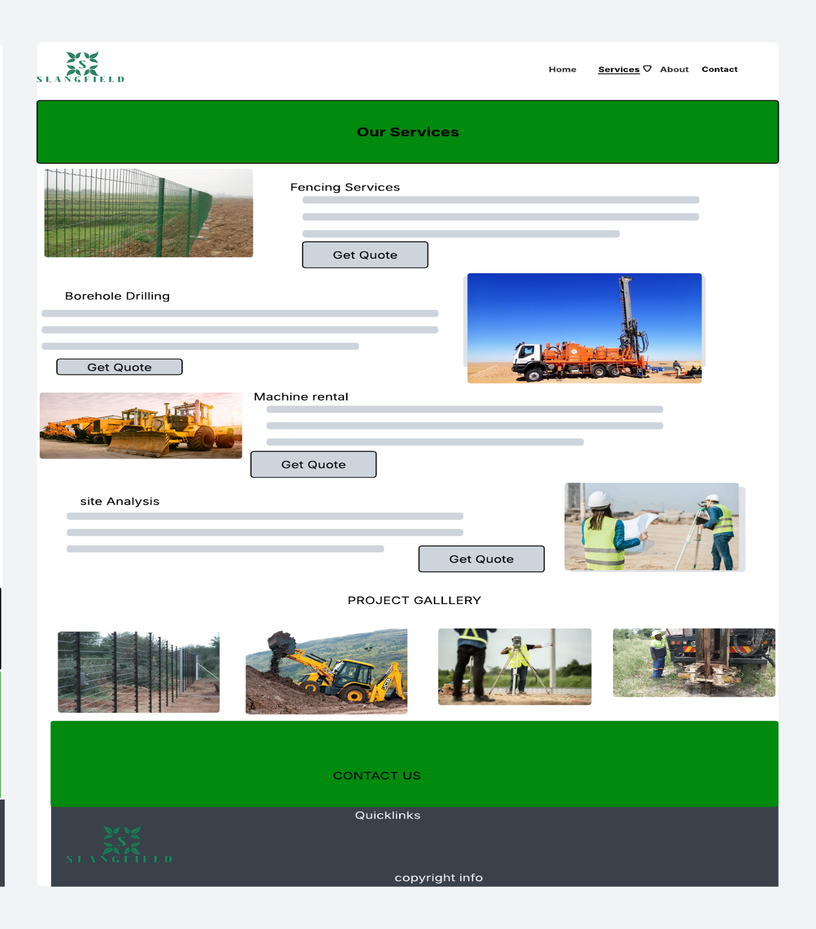
SERVICE PAGE TEMPLATE

ABOUT PAGE TEMPLATE
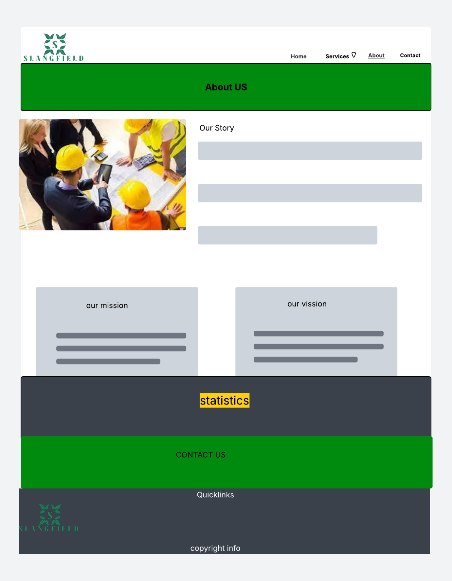

CONTACT PAGE TEMPLATE
